Guide to registration on the public procurement portal
Contenst
Guide to registration on the public procurement portal 1
Registration of the user with a request to the Information system of the Tax Committee of the Republic of Tajikistan 1
User Registration (Manual) 2
Editing a user profile 6
Registration of an organization with a request to the Information System of the Tax Committee of the Republic of Tajikistan 8
Registration of organization (Manual) 9
Submission of an application of the user (staff member) of a registered organization 11
Addition of Bank Details 12
Management of the organization's staff powers 14
Editing the user profile 15
Log in of a registered user 19
Downloading files 21
File Catalog 22
Downloading files from the repository 26

Registration of the user with a request to the Information system of the Tax Committee of the Republic of Tajikistan
To pass the user registration procedure in the public procurement system by requesting data from the Tax Committee of the Republic of Tajikistan IS it is necessary to follow the "Register with Tax Committee" tag in the portal entry form
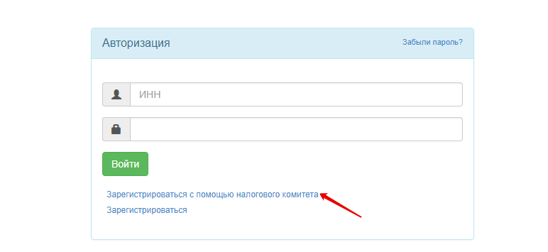
It is necessary to enter the user's INN in the request form that appears.

User Registration (Manual)
To pass the user registration procedure in the public procurement system by manual data entry and subsequent approval of the application for registration with the Agency for Public Procurement of Goods, Works and Services under the Government of the Republic of Tajikistan it is necessary to follow the "Register" tag in in the portal entry form

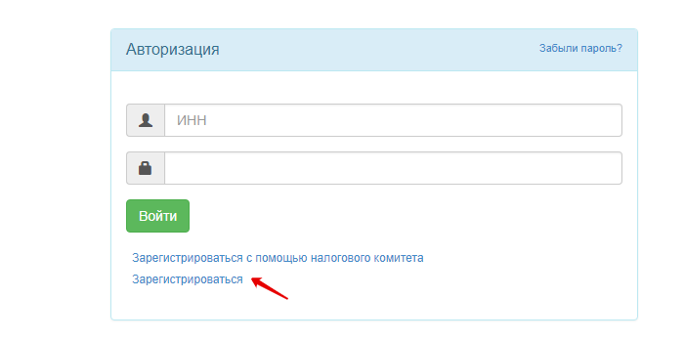
The following fields in the user registration form should be filled in:
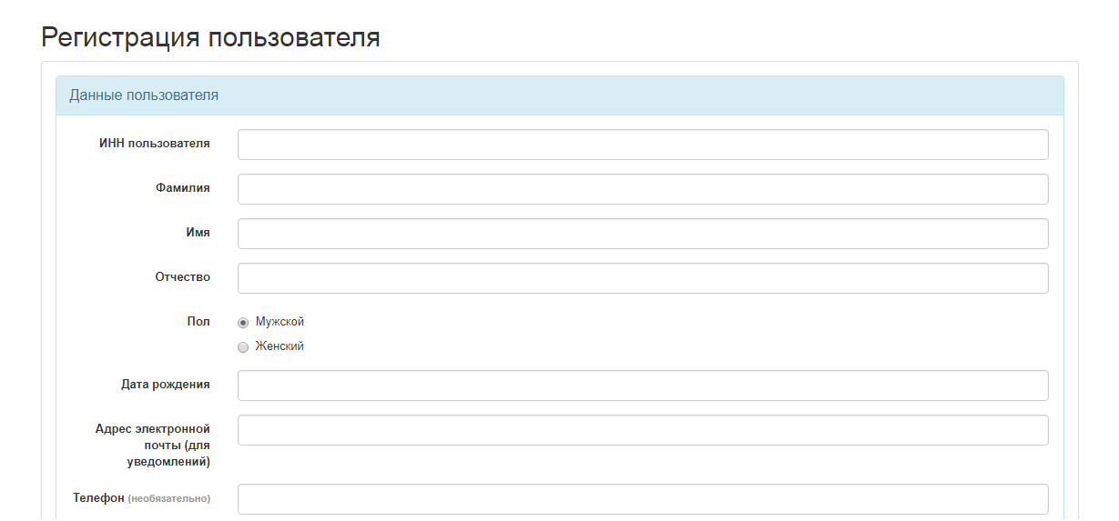
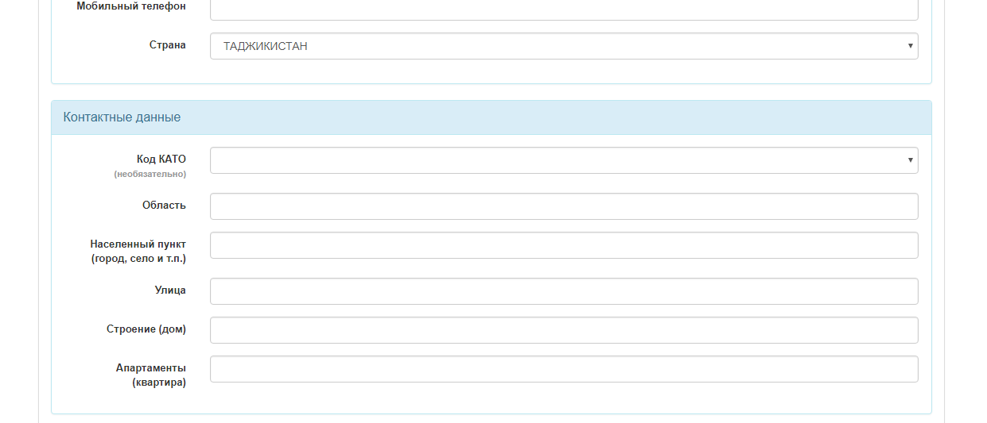
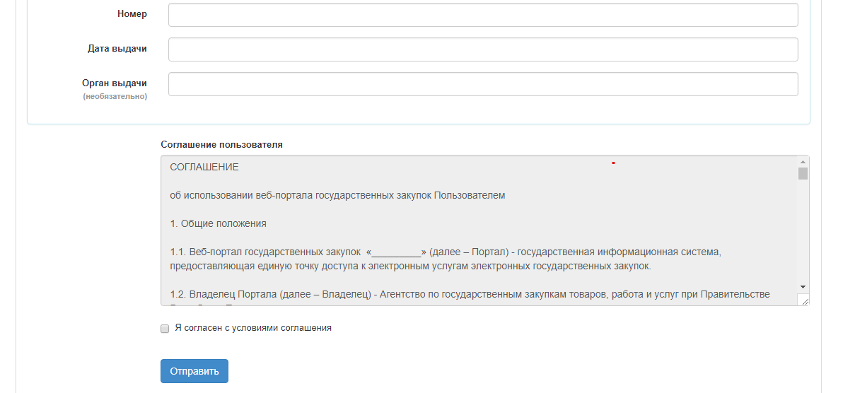
The user must accept the terms of the User Agreement before clicking the "Send" button.
After clicking the "Send" button, the system automatically sends a link to the email address specified during the registration of the user to activate the mail.
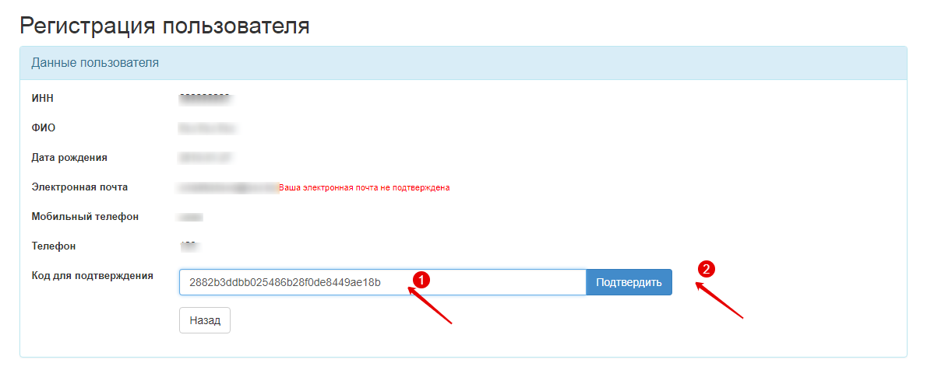
On the mail activation form, the user should enter the code received in the notification and click the "Confirm" button
After the mail is activated, it is necessary must click the "Submit the User Registration Application" button
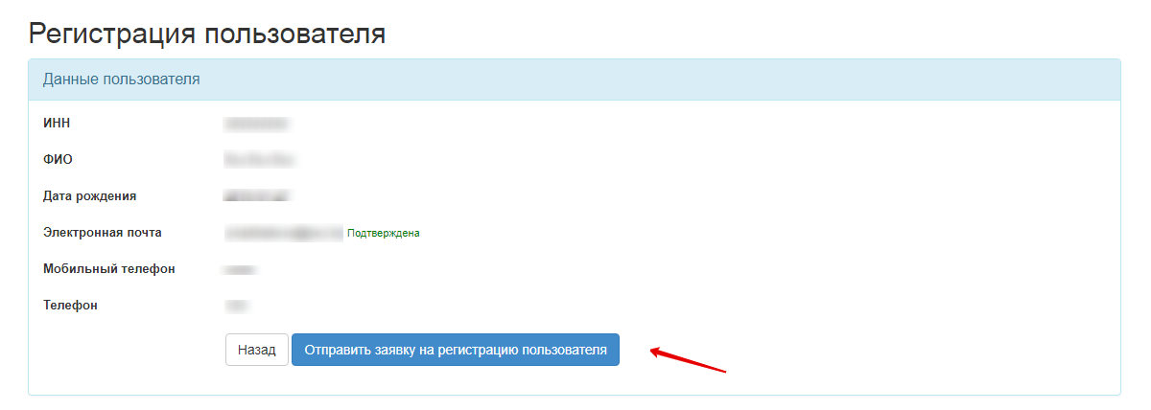
After the user registration application has been submitted for approval to the RT PPA, the application is assigned "On Confirmation" status.
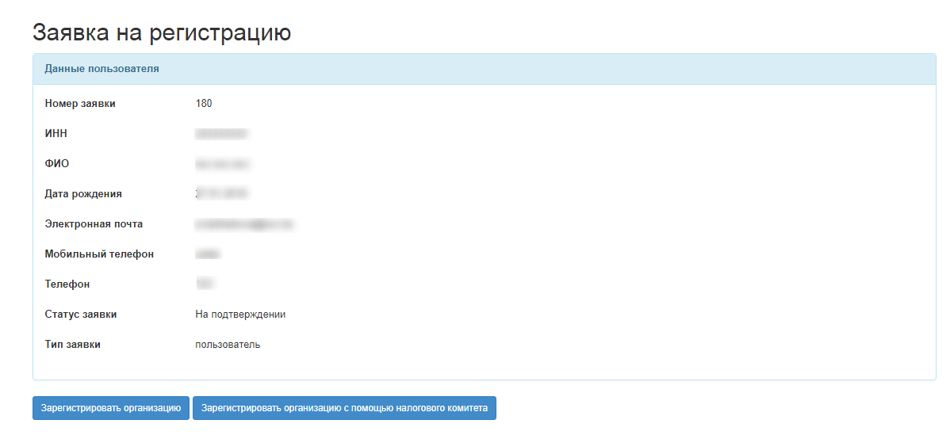
Note. The user will be able to assign a password to log in only after the application has been confirmed by the authorized body (RT PPA).
After the application is sent for registration with the RT PPA, the user receives a notification with the link to review the application status to the e-mail address.
If the application to register the user is rejected by the RT PPA, the user should repeat the registration procedure.
After the user application is confirmed by the RT PPA, the user is sent a notification with a link to assign a system log in password to the e-mail address.
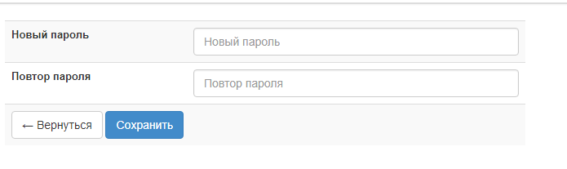
Note. When assigning a password, the system checks it for the number of characters: at least 8 and not more than 20 symbols and containing at least 1 letter and 1 digit.

Editing a user profile
Editing a user profile is made in the Personal Account- Personal Information-Registration Data menu :
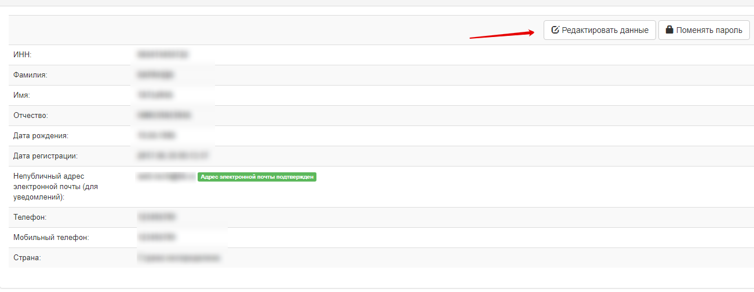
Click "Save" button to save the adjustment made to the data in the form. When saving the data, the compulsory filling in of the e-mail address will be verified, in case of successful verification, the Web portal will display the user's data review form. To verifya message to the specified e-mail address, click "Confirm email address" button. Upon the click of this button, the Web portal will send a message with an auto-generated link to the saved e-mail address following which will confirm the option of sending messages to the specified address and the status of the e-mail will be changed to "Confirmed".
Editing a user password is made in the Personal Account- Personal Information-Registration Data - Change Password menu :
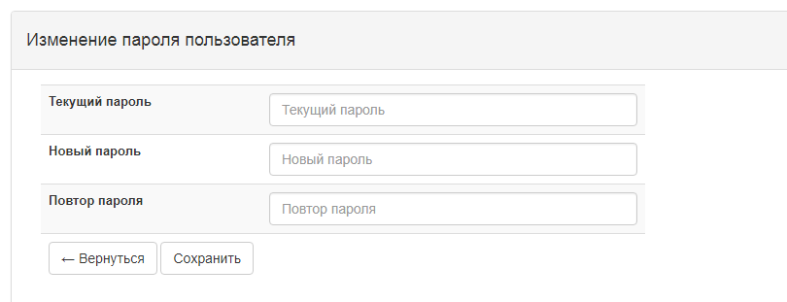
The "Current Password" field requires entry of the valid password. The "New Password" field requires entry of a new password, at that the length of the password should be from 8 to 20 characters. The password must contain lowercase, uppercase letters and digits; the "Confirm Password" field requires re-entry the new password to avoid incorrect password input.
Editing a user's passport data is made in the Personal Account- Personal Information-Passport Data menu :
Clicking the "Add" button moves you to new user details addition form.
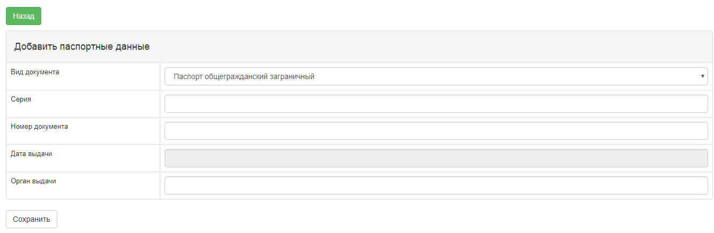
Clicking the "Edit" button moves you to the form of the selected user details adjustment (available only for manual details entries).
Clicking the "Delete" button prompts a request to confirm the deletion the selected user details (available only for manual details entries). The detetion is made upon the confirmation ("Yes" button). In case of cancellation ( "No" button) the return to the Passport Data View form is carried out.
Editing of the user's contact information is made in the Personal Account- Personal Information-Contact Information menu
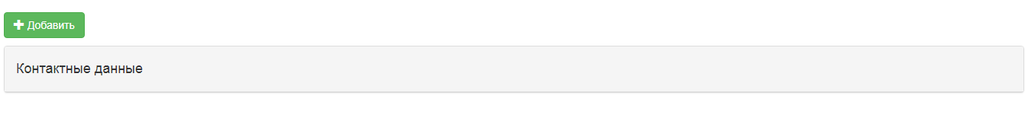
Clicking the "Add" button moves you to contact information addition form.
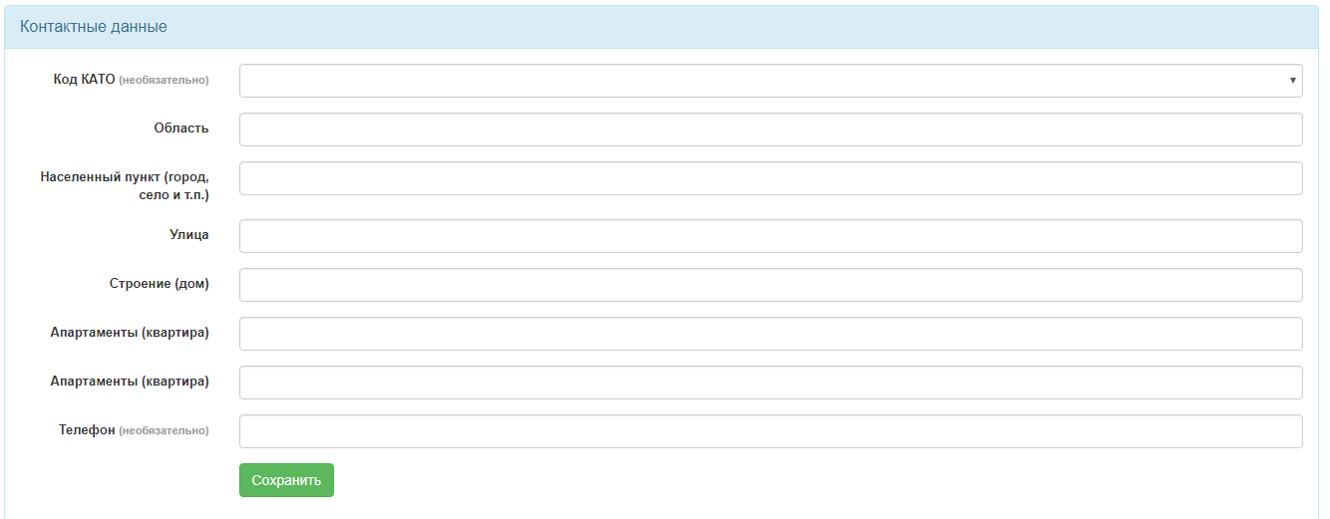
Clicking the "Edit" button moves you to the form of the selected user details adjustment (available only for manual details entries).

Registration of an organization with a request to the Information System of the Tax Committee of the Republic of Tajikistan
To pass the user registration procedure in the public procurement system by requesting data from the Tax Committee of the Republic of Tajikistan IS it is necessary to follow the "Register an Organization with Tax Committee" button in application review form.
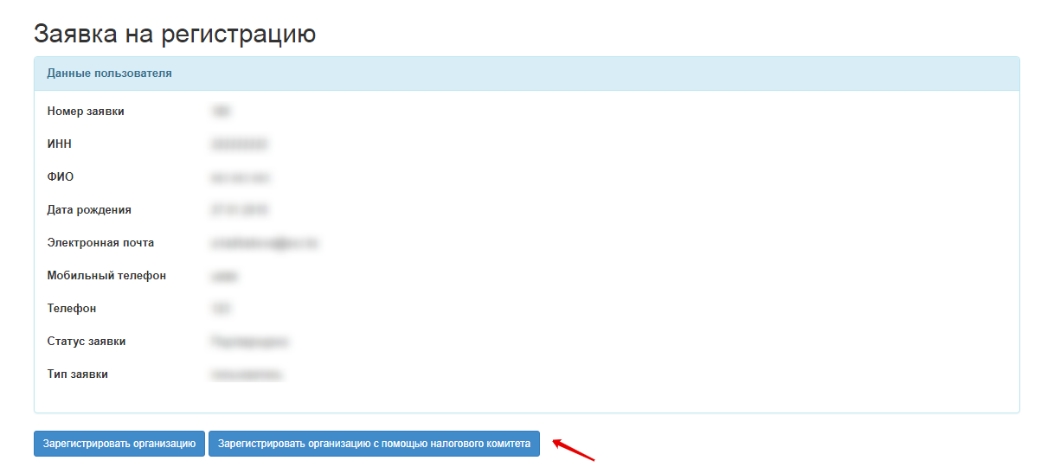
Registration of an organization is also available after the confirmation of the user registration application. For this, after the user assigns a password to log in and authorized, it is necessary to follow the "Register an Organization with Tax Committee" hyperlink in the Personal Account.
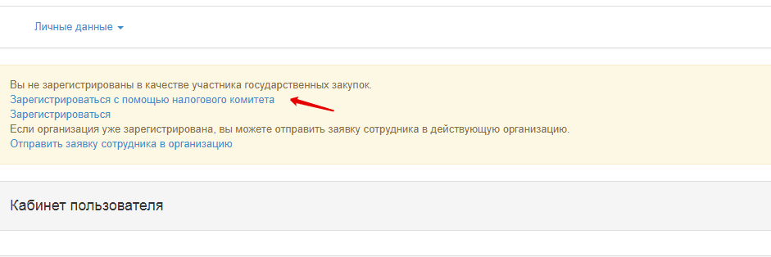
In the Organization Registration form it is necessary to enter the organization's INN to obtain the INN data, organization informationfrom the Tax Committee IS.
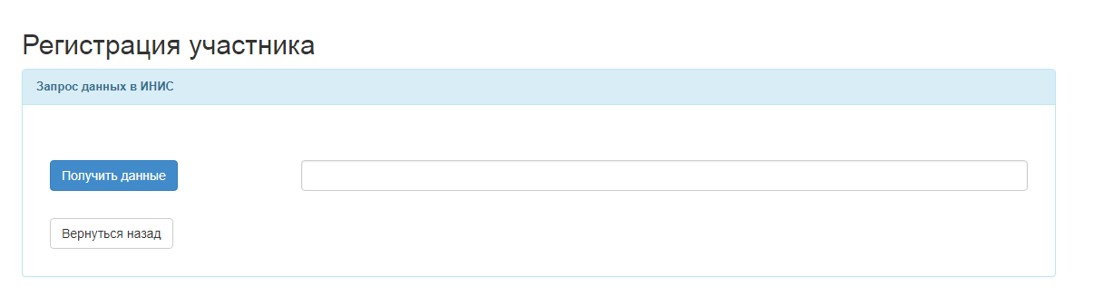

Registration of organization (Manual)
To pass the organization registration procedure in the public procurement system by manual data entry and subsequent approval of the application for registration with the Agency for Public Procurement of Goods, Works and Services under the Government of the Republic of Tajikistan it is necessary to follow the "Register an organization" button in the user registration application review form.
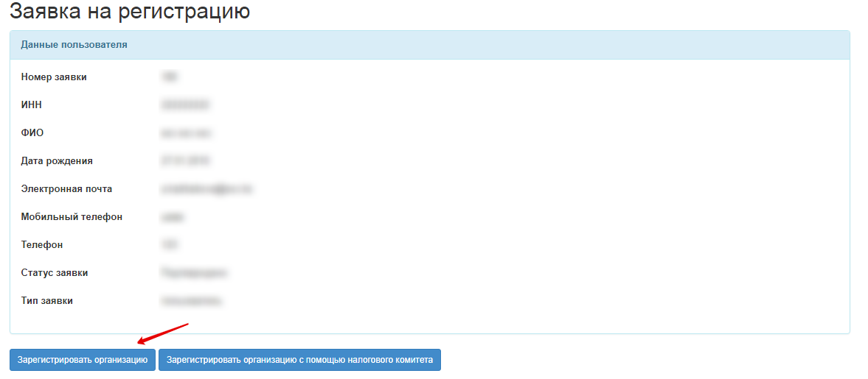
Registration of an organization is also available after the confirmation of the user registration application. For this, after the user assigns a password to log in and authorized, it is necessary to follow the "Register" hyperlink in the Personal Account.
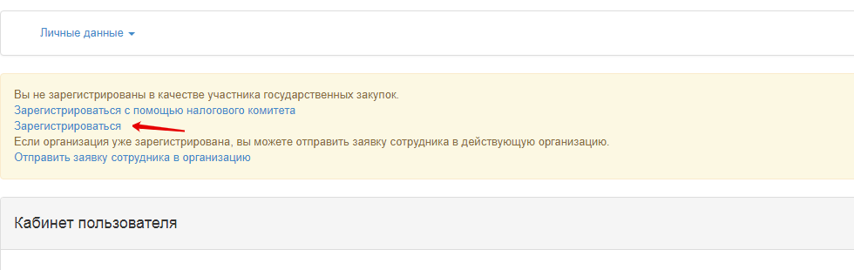
In the Participant registration form, it is necessary to fill in the fields and accept the participant agreement terms.
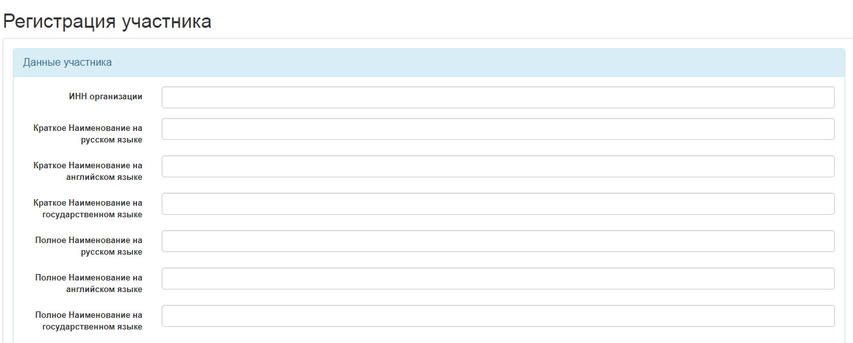
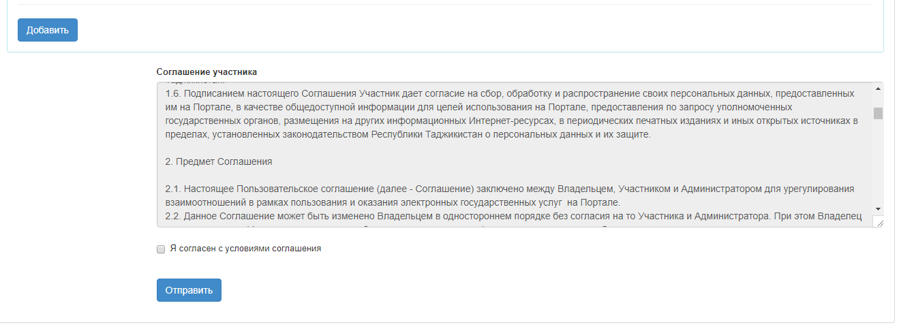
After the user registration application has been submitted for approval to the RT PPA, the application is assigned "Under Confirmation" status.
Note. If the application to register the participant is rejected by the RT PPA, the user should repeat the registration procedure.
After the participant's application is confirmed by the RT PPA, a notification of application confirmation is sent the user's email address. The functions in accordance to the roles selected during the registration of the organization become available to the user.

Submission of an application of the user (staff member) of a registered organization
If the user is only undergoing the registration procedure on the portal, but the organization of which he or she is a staff member is already registered with the system, it is necessary to undergo user registration procedure. The status of the user registration application should be "Confirmed". After the it is necessary to need to log in. The user should follow "Send an employee's request to the organization" link in the Personal Account.
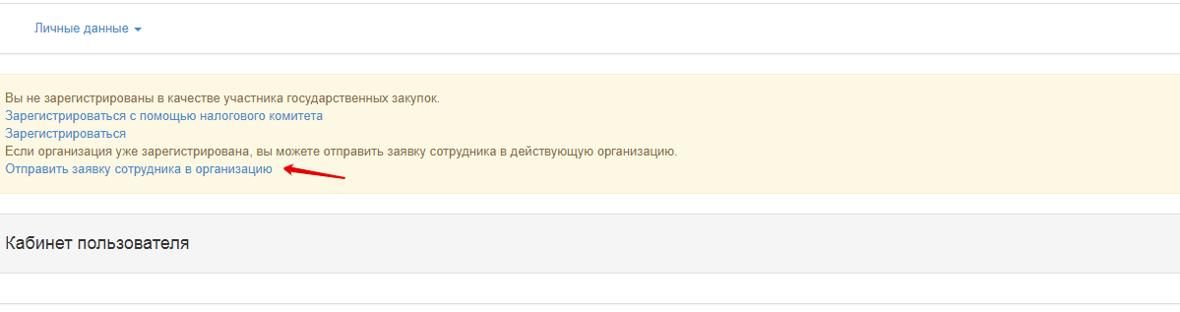
Then it is necessary to enter the INN of the registered company.
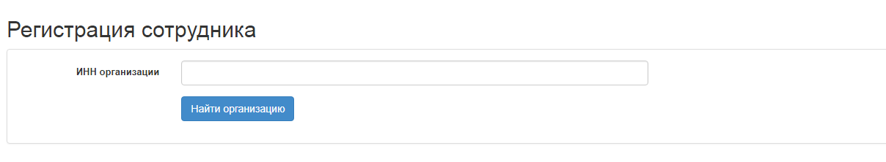
After the search of the registered organization, it is necessary to click the "Send an employee's request to the organization" button
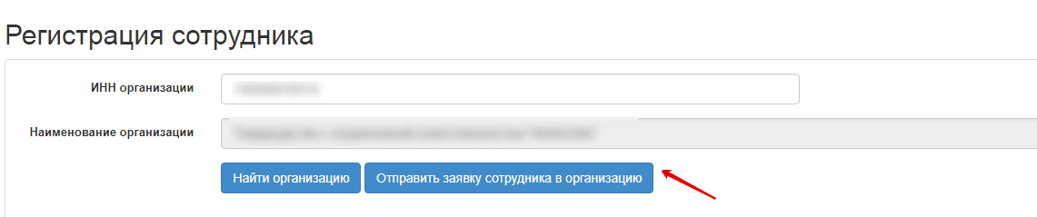

After the application is submitted, the user will be displayed in the list of employees of the selected organization. The powers to work in the system will be available after the Administrator of the selected organization assigns the appropriate roles.

Addition of Bank Details
In case the bank details are not filled in, the Web portal will suggest to fill in information about the bank details.
To do this, it is necessary enter the Participant profile section, the Bank Accounts submenu.
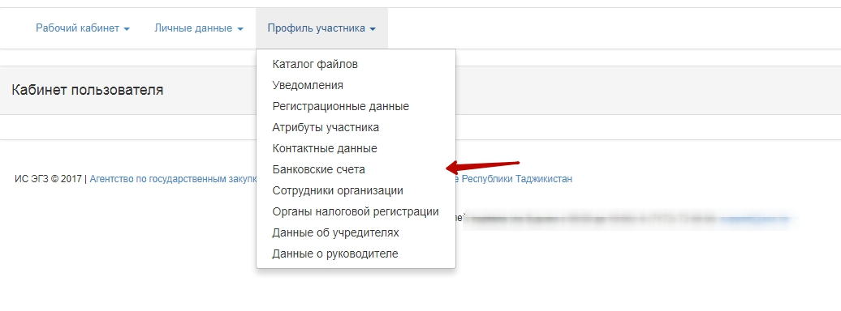
Note. Addition of bank details is available to the user acting the role of the Organization's Administrator.
In the Addition of Bank Account form, it is necessary to click the "Add" button
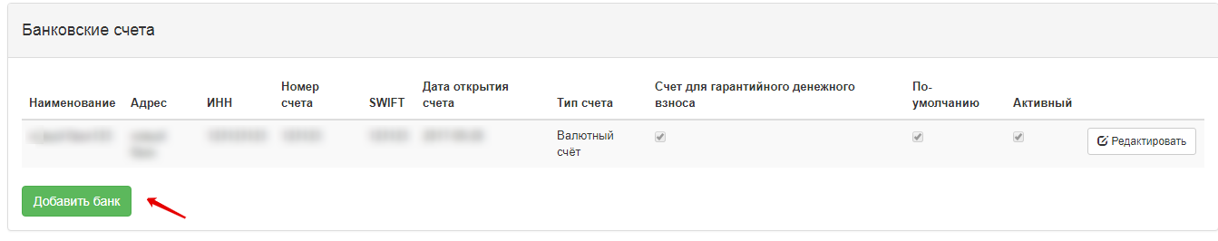
In case of the necessity to edit the bank accounts, it is necessary to click the "Edit" button
In the Addition of a New Bank form, it is necessary to fill in the fields and then click the "Save" button
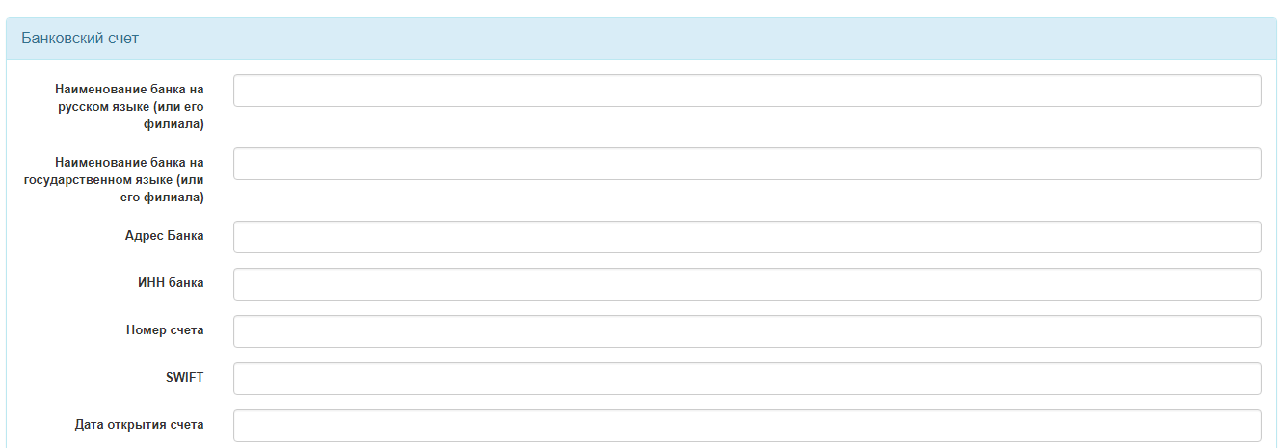
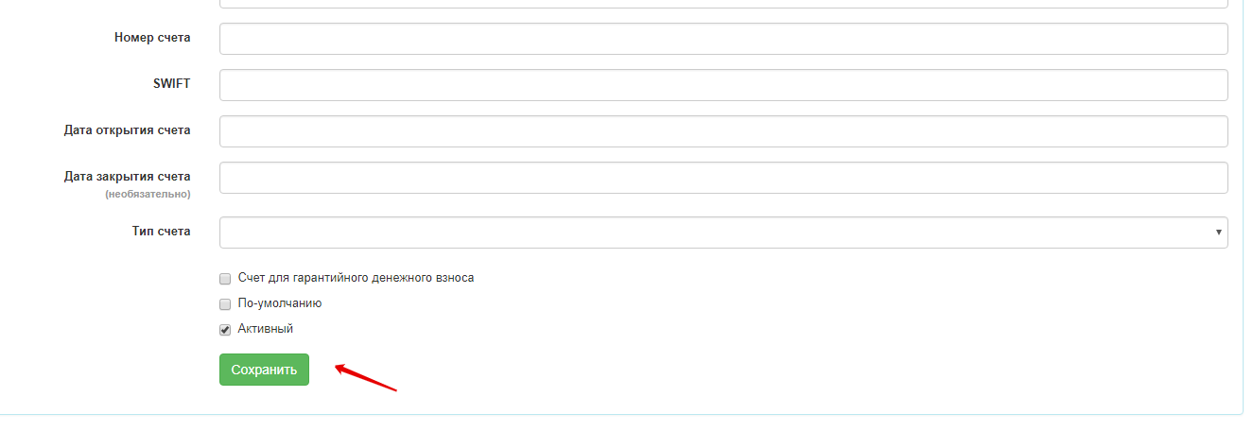
After the save of the bank account, the data will be displayed in the Bank Accounts section.

Management of the organization's staff powers
Assigning or modifying the staff powers is done by a user with "Organization's Administrator" power, this may be the user registering the organization and/or the head of the organization and/or any employee of the organization (there is an option to transfer the assignment of powers). To assign/ change the powers of the participant's staff, the Organization's Administrator should log in into the Personal Account, then move to Participant's Profile menu and then choose the "Organization's Employees" item, after that the following menu appears:
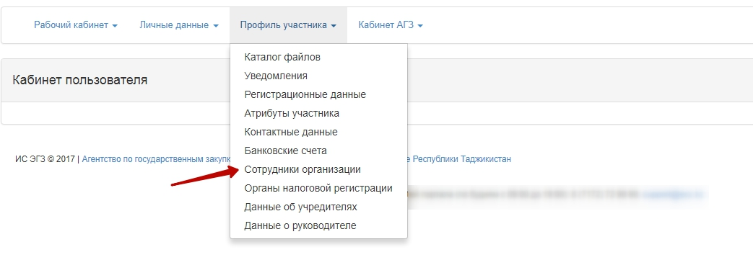
It is necessary to click the "Edit the Powers" button to assign/change powers in the organization's employee review form.
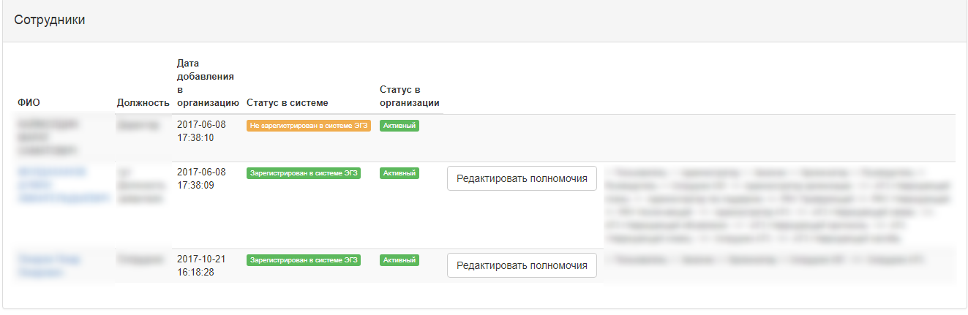
After that, the following window is displayed:
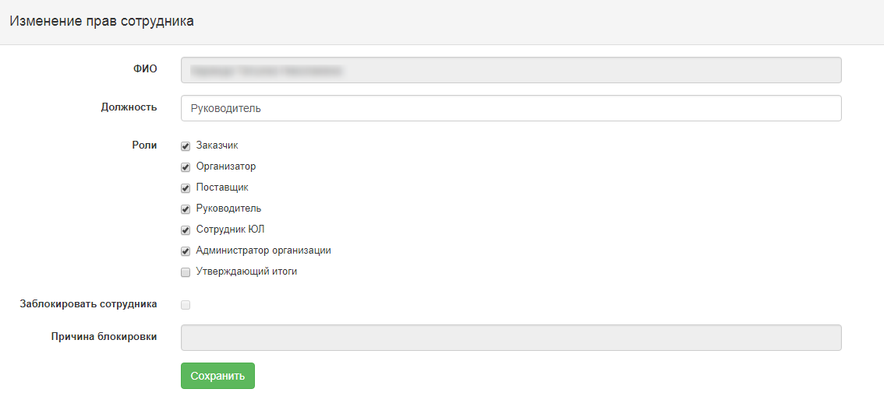
To block the organization's employee, tick the "Lock an Employee" field and enter the reason for the blocking in the "Reason for Blocking" field. After filling in all the data, click the "Save" button. The System saves the amended data, and the selected employee will be assigned/blocked the selected powers at the subsequent logon.

Editing the user profile
Adjustment of participants data is only available for the participant's employees with the Organization's Administrator role. Editing a user profile is made in the Personal Account- Participant profile-Registration Data menu :
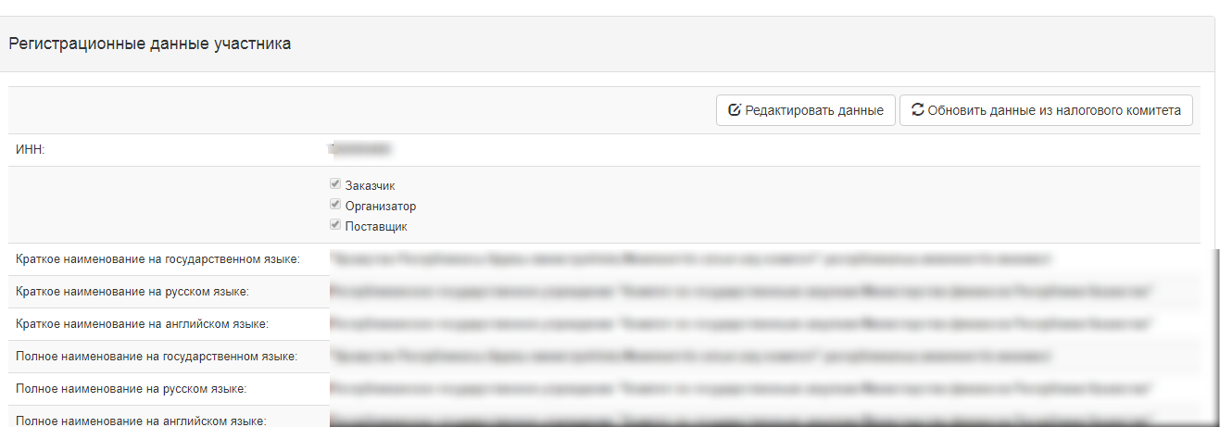
Clicking the "Edit Data" button opens the Edit Participant's Data page with the option to edit it. Clicking the "Update Data from Tax Committee" button will automatically update the data from the Tax Committee's IS.
Click "Save" button to save the adjustment made to the data in the form.
Editing the attributes of the participant is made in the Personal Account- Participant profile - Participants Attributes menu :
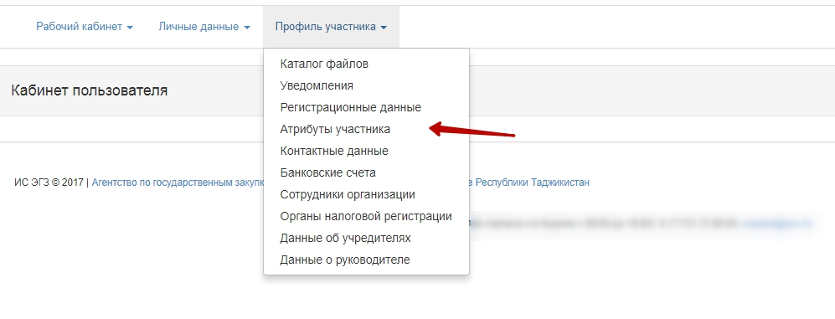
Clicking the "Save" button will save the introduced amendments.
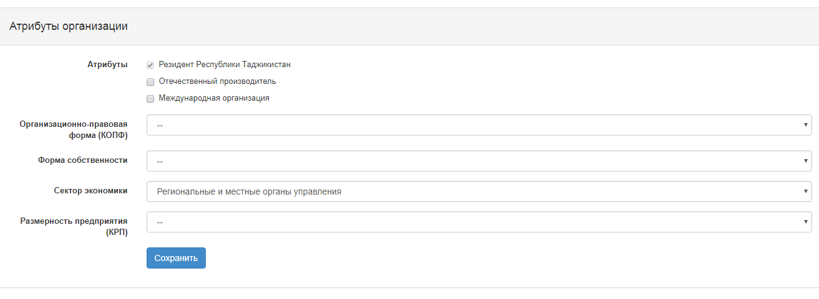
Editing of the participant's contact information is made in the Personal Account-Participant's Profile-Contact Information menu
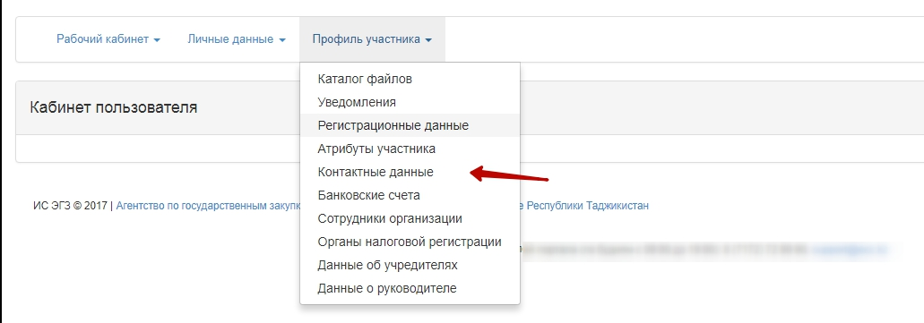
Clicking the "Add" button moves you to organization's contact information addition form.
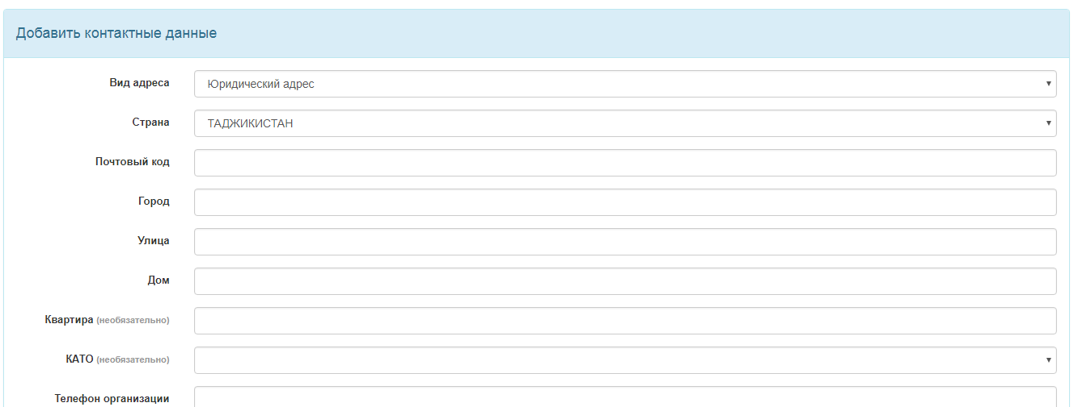
Clicking the "Save" button will save the introduced amendments.

Editing the information on the CEO of the participant is made in Personal Account-Participant's Profile-CEO Information menu
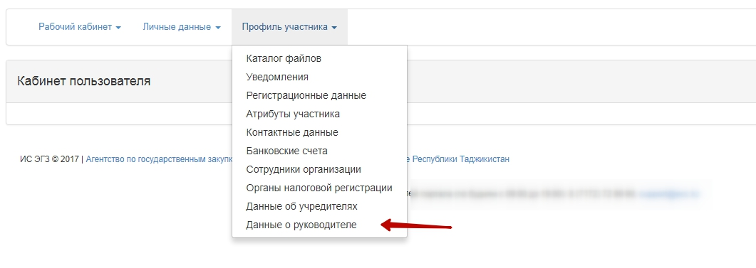
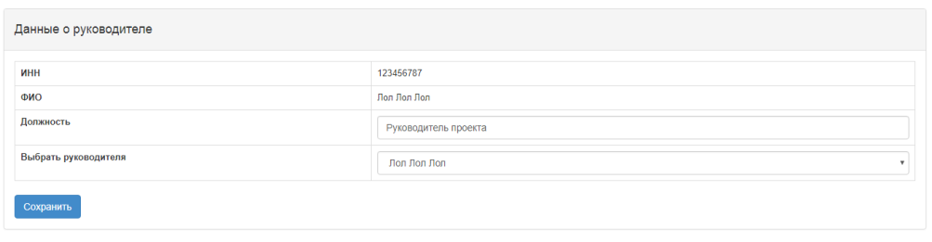
Clicking the "Save" button will save the introduced amendments.
Editing of the data on participant's incorporators is made in Personal Account-Participant's Profile-Incorporators Information (available only to legal entities)

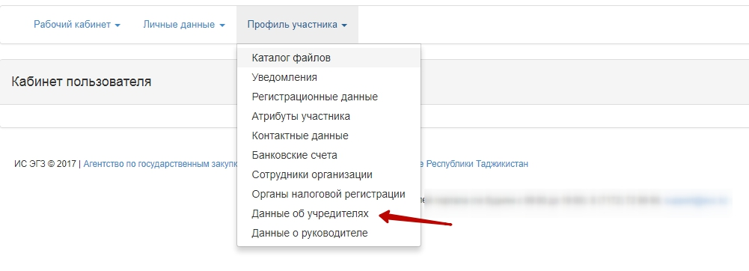
The Incorporators Information form enables users to add and edit data about the incorporators.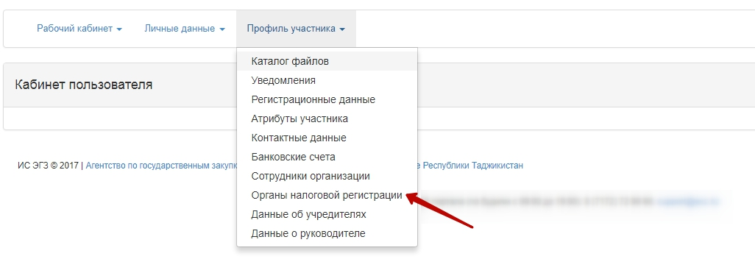
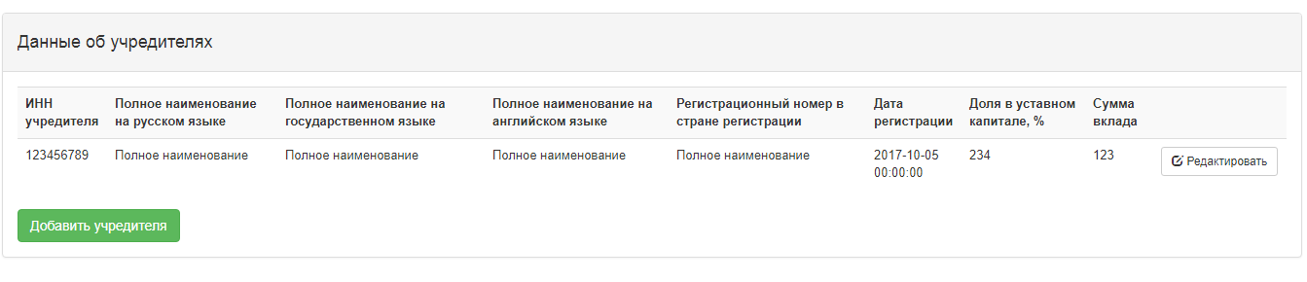
All the particpant's staff are also able to review: -Data on registration with the tax authorities. Addition of tax authority is available only to the user acting the role of the Organization's Administrator.
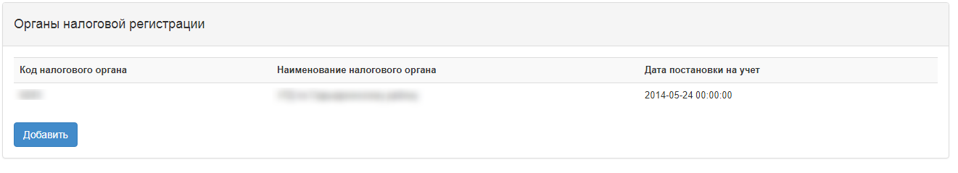

Log in of a registered user
Attention! To go to the public procurement system, it is necessary to select the "Sign in" button at Web portal home page
The Login form appears:
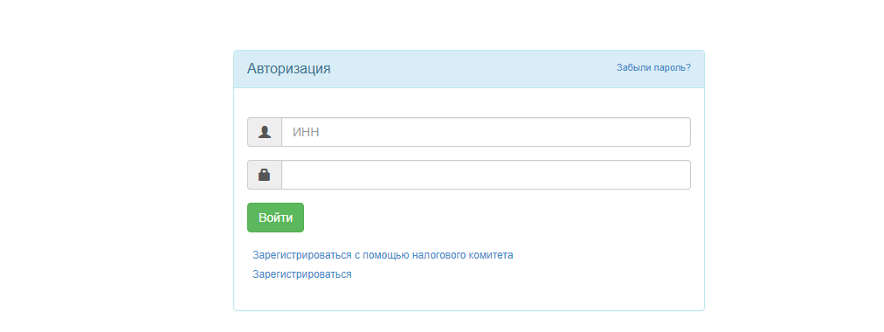
In the INN field it is necessary to enter the registered user's INN. In the "Password" field it is necessary to enter a password to log on. Then click the "Sign In" button.
The Web portal will verify the compliance of the password entered to the account and, if the validation is successful, it will display the menu and the user's home page.
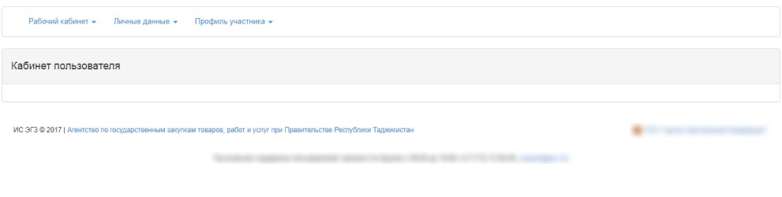
If the password entered does not comply the one set for the account, the Web portal displays the following message:

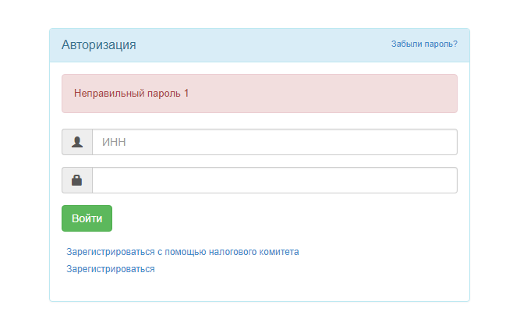
In case the entry of the wrong password 10 times in a row, the Web portal blocks the ability to log on for 1 hour, click the "Forgot Password" link to restore the password. After the click, Participant's INN entry form is displayed for subsequent sending of an email notification with the password reset link.
Go to the email you specified earlier and follow the link you received. After you follow the link, a message is displayed and the message with a temporary password and a password change instruction is sent.
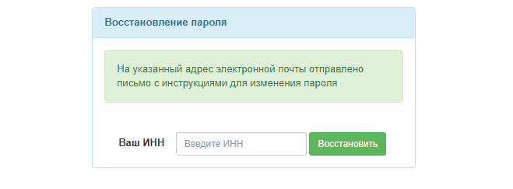
Use the password given to you to sign in to the Web portal.

Downloading files

Click the "Select File" button to download the files.
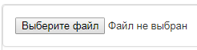
Clicking the button opens the window to find the necessary file. It is necessary to select the file and click the "Open" button

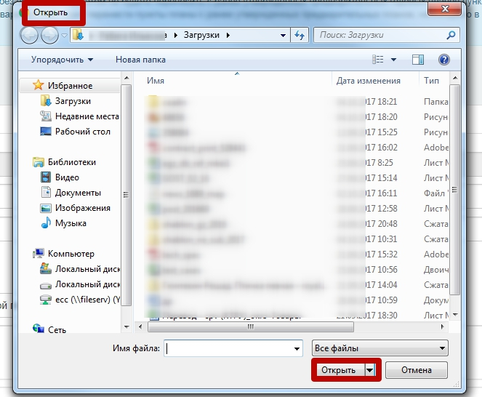

Further the check of the file being downloaded for malicious code is made.

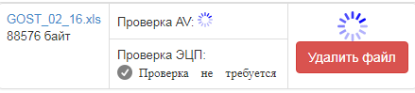

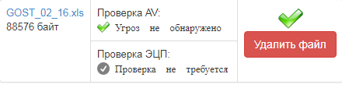

No. | Field name | Item Type | Editable? | Compulsory? | Description
1 | Select File | Button |  |  | Clicking the button displays a File Selection window. Selection of not more than one file is allowed.
2 | Open | Button |  |  | After clicking the button the file starts downloading. The file must not exceed 5000 KB.
3 | AV Check | Text tag | - | - | After the upload, a check for malicious code is made. Check results:  No threat found;  A threat detected.
4 | EDS Check | Text tag | - | - | Used when checking files downloaded using EDS.
5 | Delete a file | Button |  |  | The button is designed to delete a file.

File Catalog
All attached files are automatically included into the basket of the participant's files catalog. To work with the catalog, you must go to the Participant Profile-File Catalog section

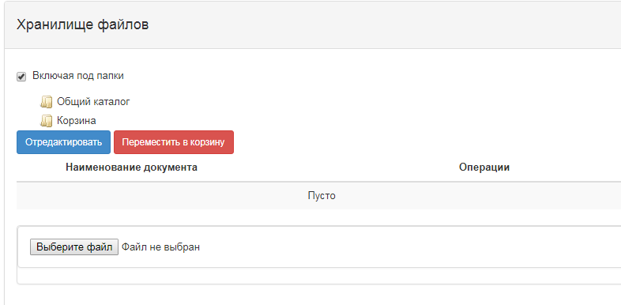
There are 2 default folders in the catalog:
- Shared Catalog;
- Basket
All previously attached files are displayed in the Basket folder:
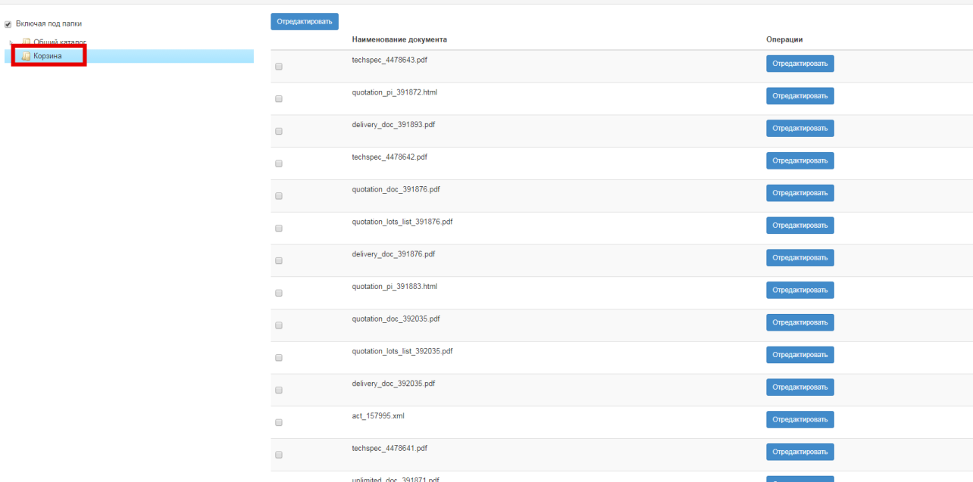
The files in the Basket are not available for use (attachment).
To be able to use the file later, it is necessary to transfer the file to a shared folder or create a new subfolder to the shared folder. To do this, right-click the "Shared folder" and click the "Create" button as shown in the following picture:
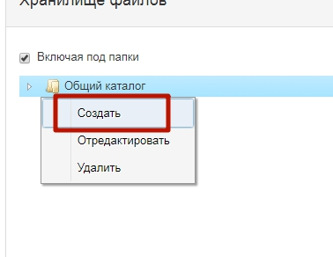
Give the folder the appropriate name:
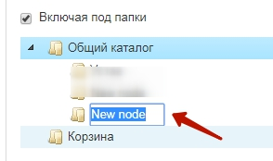

Next, it is necessary to select the desired file(s) and click the "Edit" button

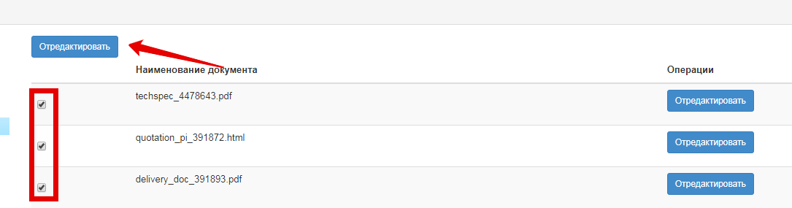

Next, select the folder where it is necessary to move the files and click the "Attach" button
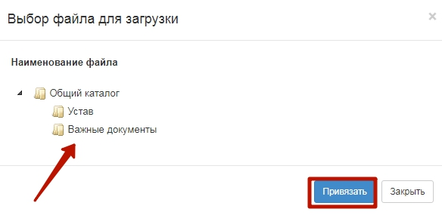

If the file is no longer used, you can move the folder back to the Basket. To do this, mark the file in the folder and click the "Move to the Basket" button
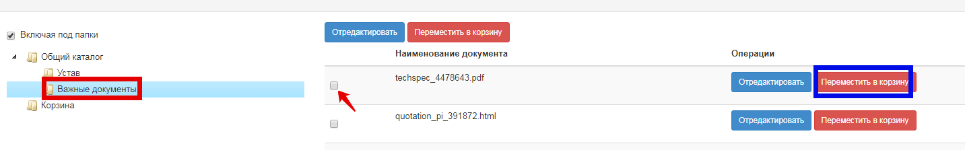

Downloading files from the repository
In the form where it is necessary to attach a file, there is an option to attach the file from the catalog.
To do this, click the "Select from Catalog" button.

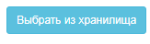
Clicking the button opens the file selection form from the catalog folders:

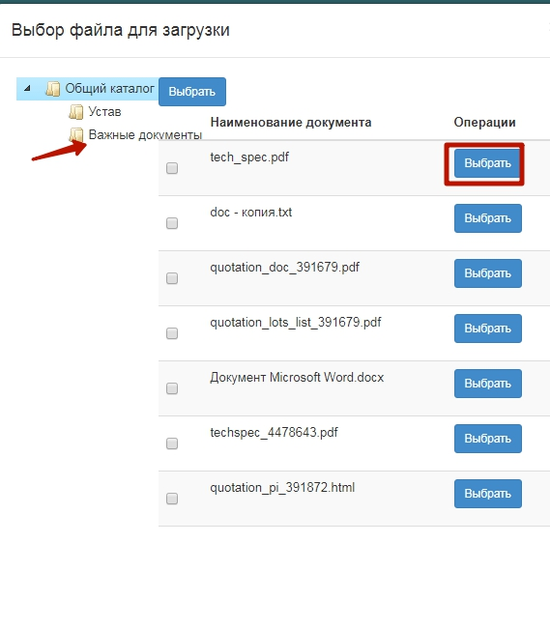
Attention! Catalog Basket files are not available for selection
It is necessary to click the "Select" button on the line with the desired file. Then the download of the file is made.